BugSeeker Applications

Login Page:

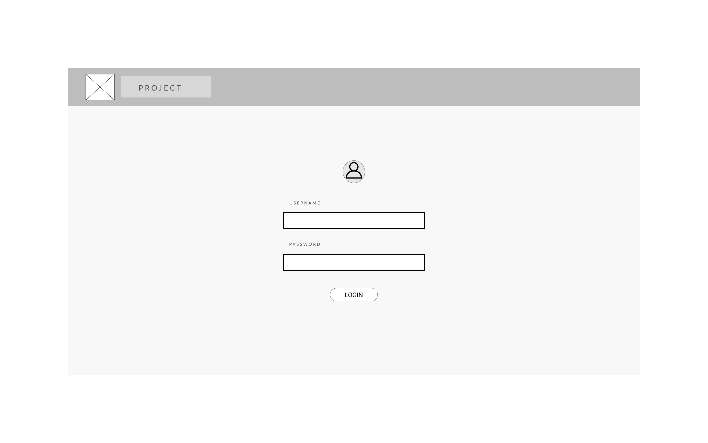

Admin Dashboard:

Create Bug:

View Bug:

